

Kamel Almarji

Jordan Interctive Electronic Reporting system (JIERS) Referance Manual (user)

Contents

1. Introduction 3

2. Intended Audience 3

3. Locked Apps 3

4. Login screen 4

5. Main menu 5

6. Changing the language 6

7. Sample form 8

# Introduction

This is a reference manual for the JIRES system, this manual describes the slandered user tasks for the new JIERS system.

# Intended Audience

This Manual is intended to be used by the MOH end users at the medical centers.

# Locked Apps

The tablet has an application that locks all the applications of the tab other than the JIERS app, if you open a locked application the following screen will appear. If you think you need to use a certain application on the tab and its locked you have to ask your IT administrator in the health center as he/she can unlock the application.

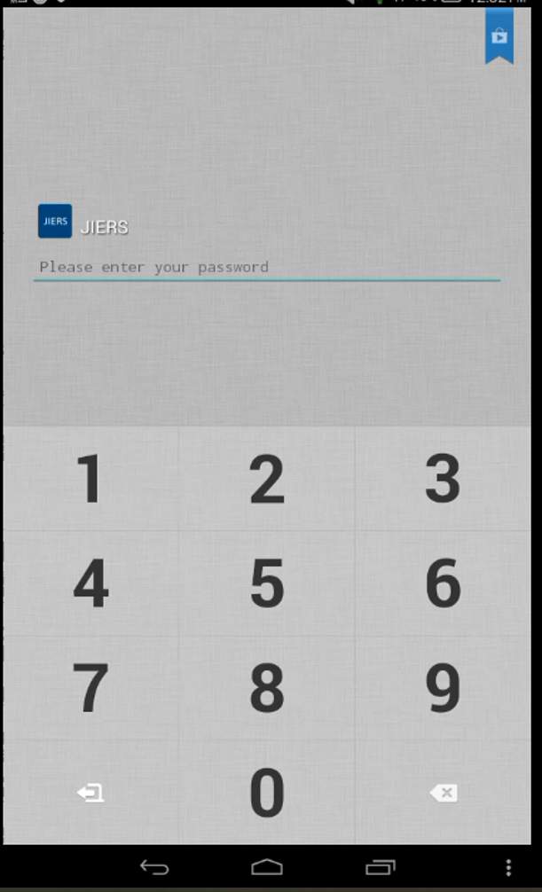

# Login screen

This is the login screen of the system, the IT department in the MOH must provide each user with their own username and password to login to the system.

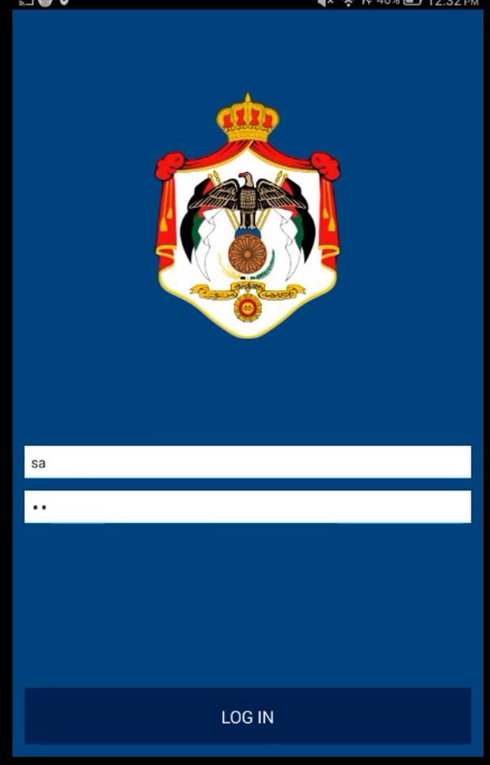

# Main menu

This is the main menu of the system.

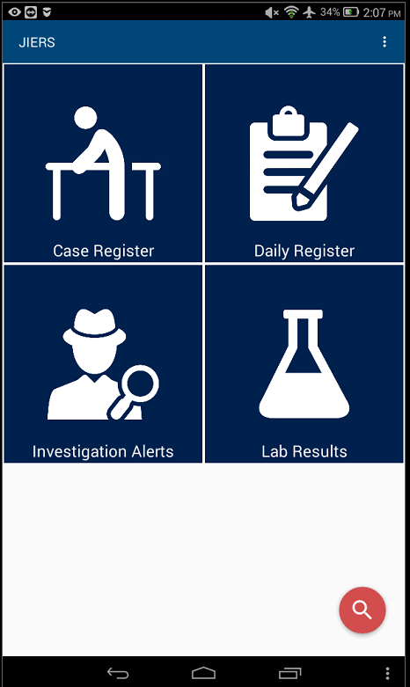

# Changing the language

To change the language press on the three dots at the top of the right screen, tap on settings and then chose the language you want.

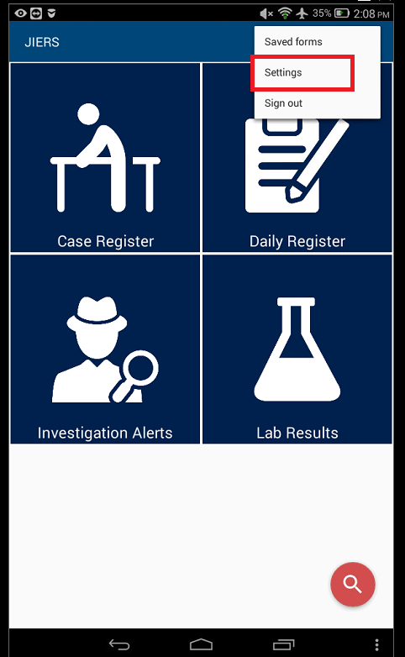

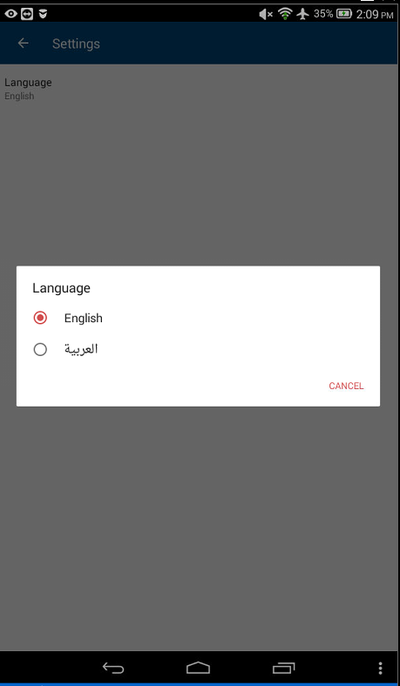

# Sample form

This is sample form, there

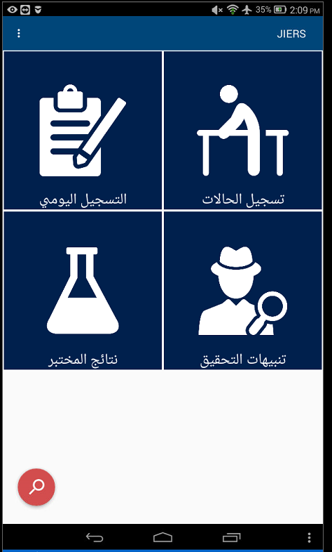

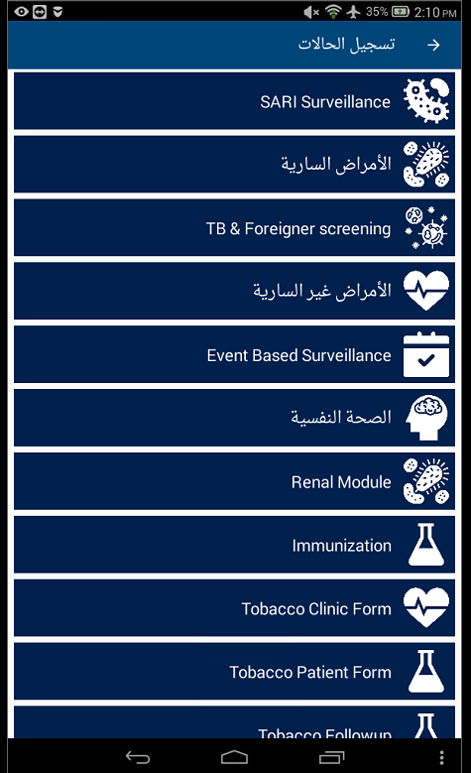

1. Mandatory field

Each mandatory field has a red star beside its name; you cannot continue the form if this field is not filled.

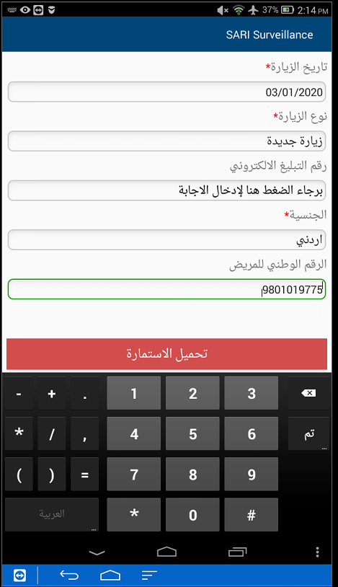

1. Dependent fields

Some field are depended on other fields such as the national ID field is dependent on the nationality field.

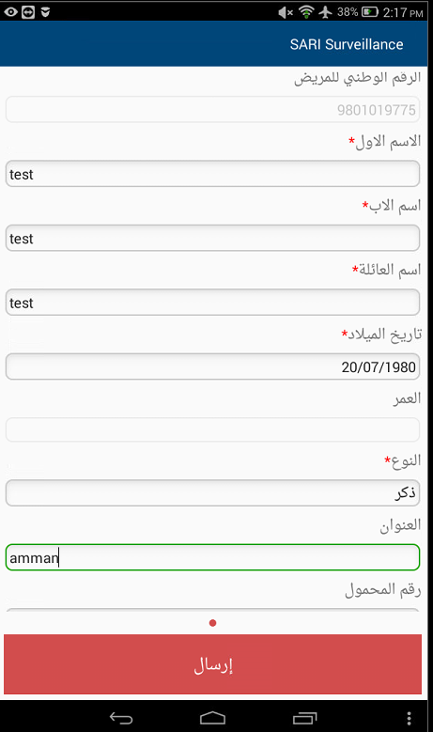

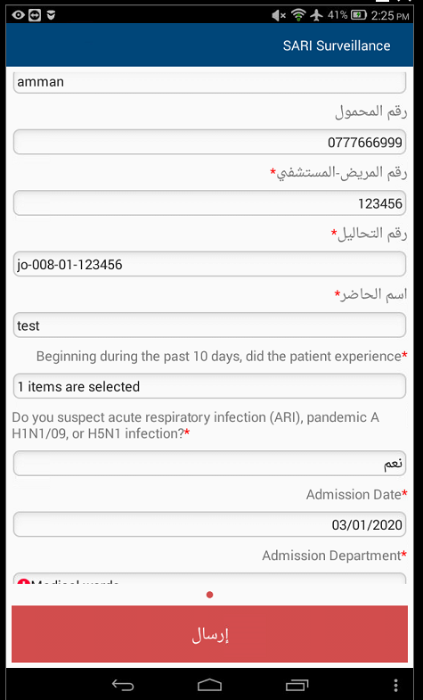

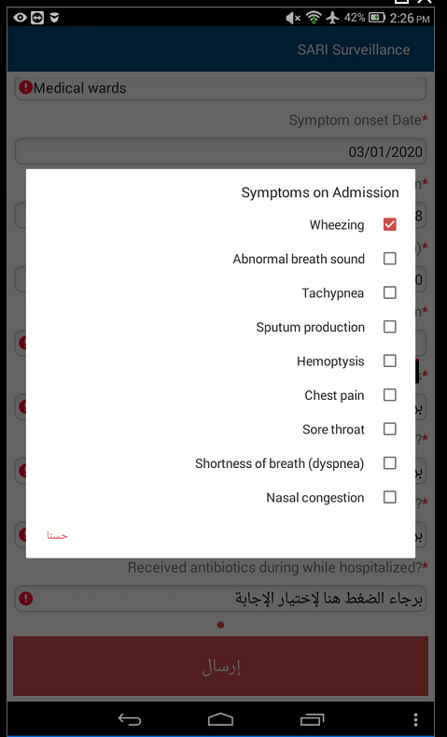

1. Missing input

If a mandatory field is not filled and you try to move forward, you will get a red exclamation mark.

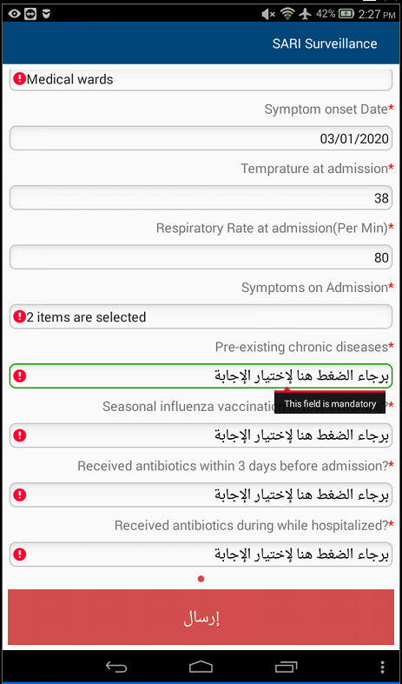

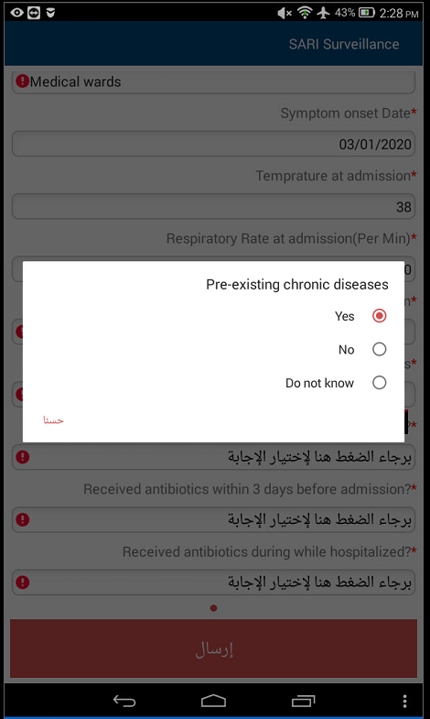

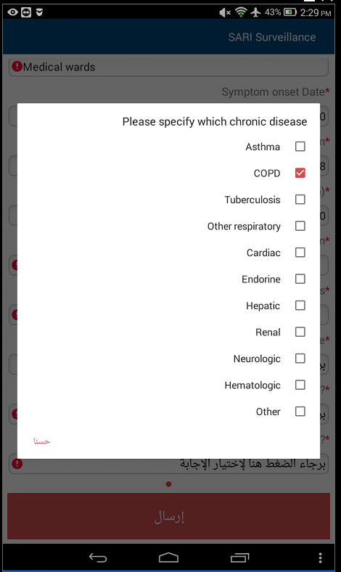

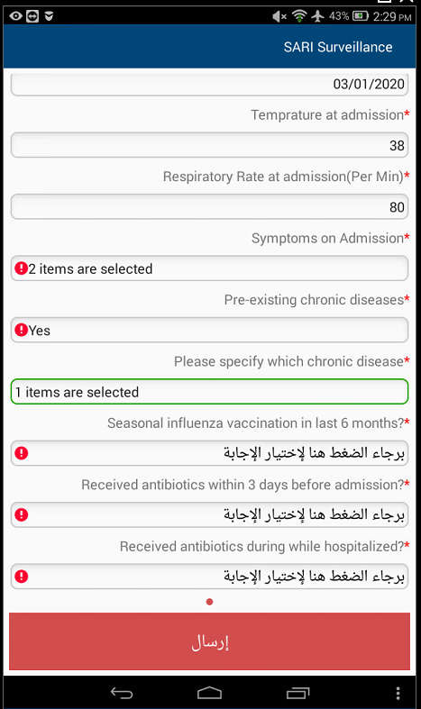

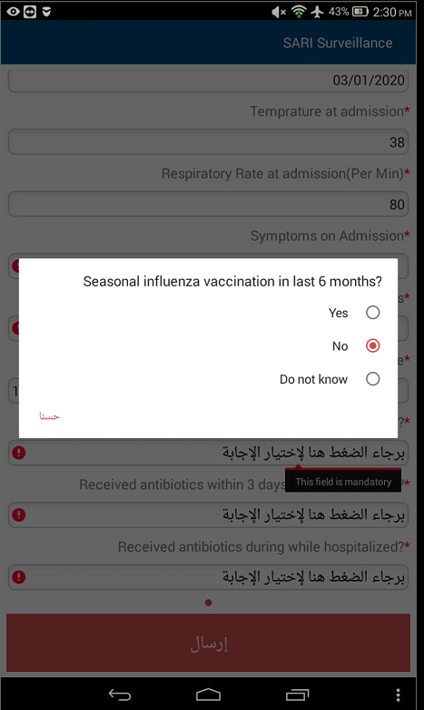

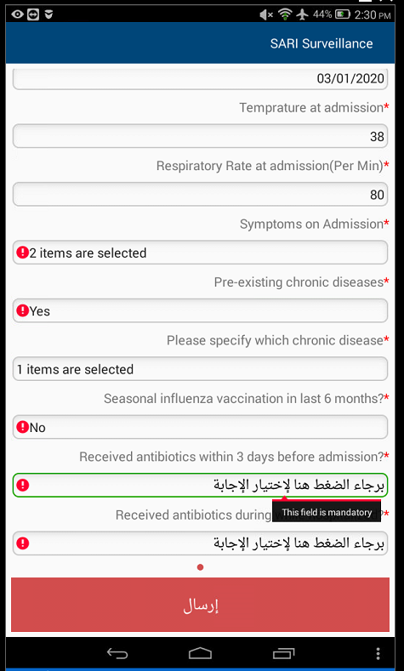

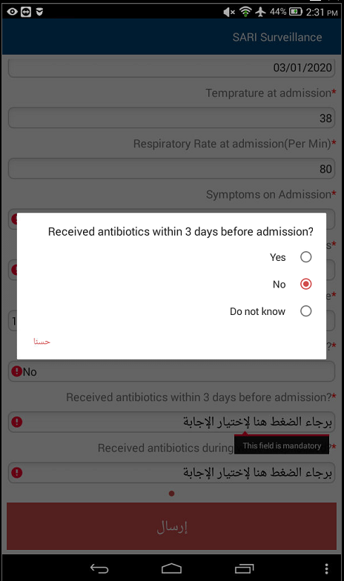

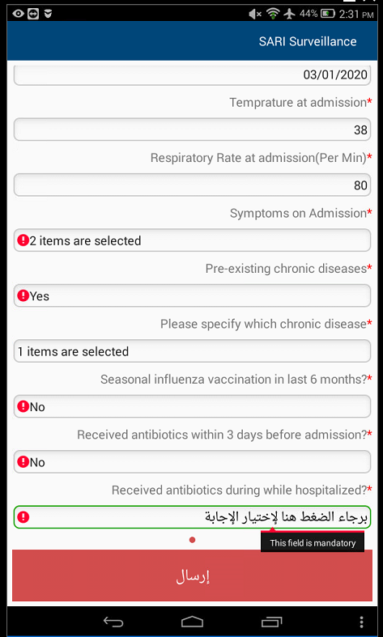

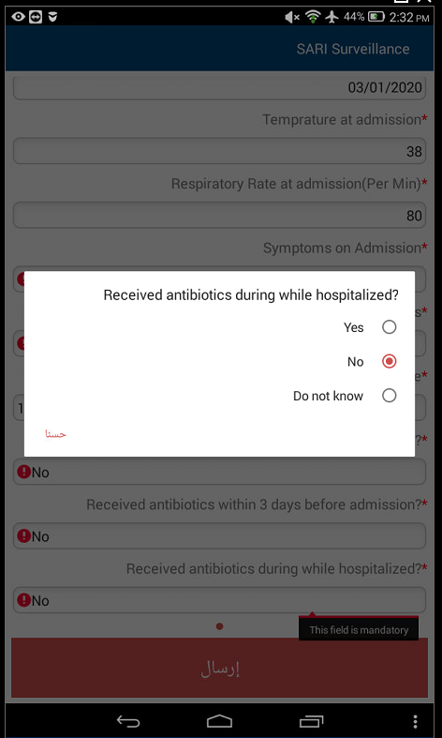

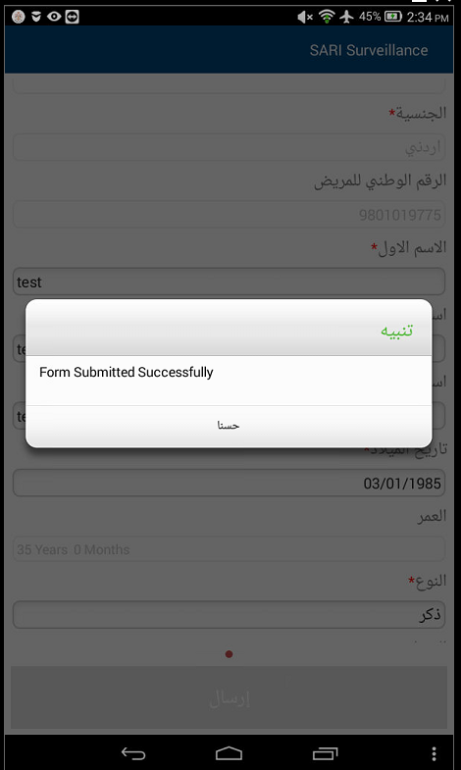

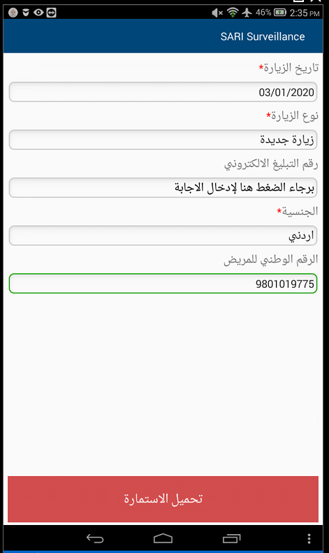

# Offline mode

The application supports offline mode, so you can use the application to collect the data even if there is no connection to the server.

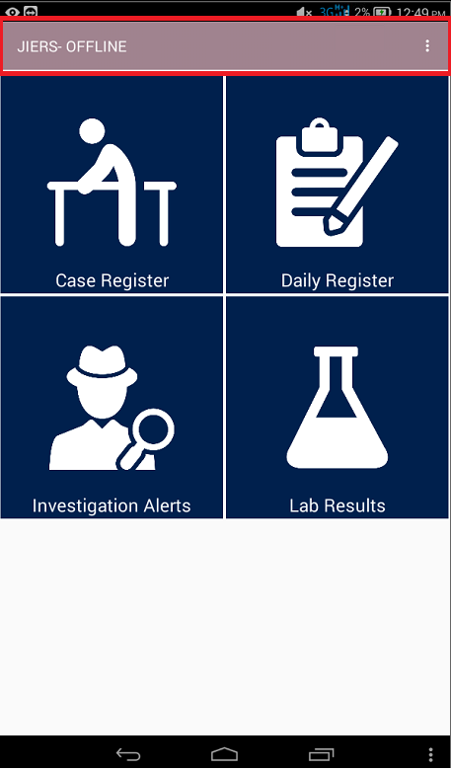

Once you input a form in offline mode you can view it by pressing on the three dots and tapping saved forms

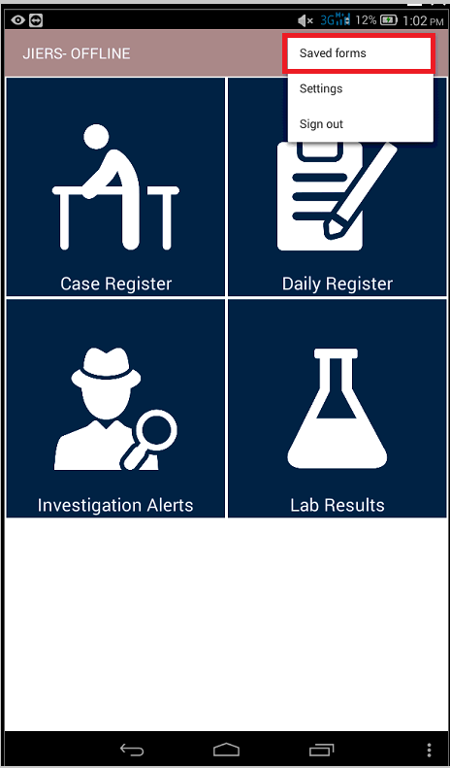

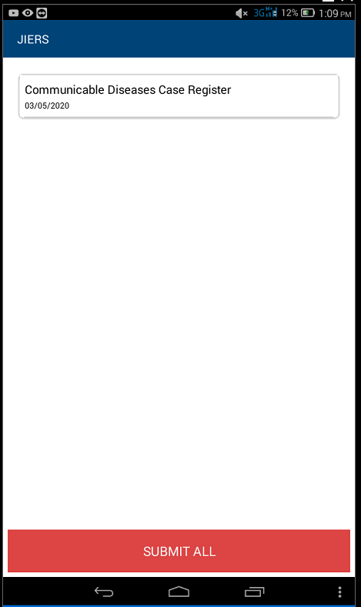

Once the tablet is online you can tap submit all